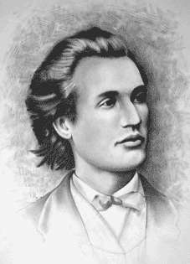

Barem clasa a VIII a

SUBIECTUL I: ( 5 puncte fiecare subiect):
1 | 2 | 3 | 4 | 5 | 6 | 7 | 8 | 9 | 10
$$2^{\text{2048}}−1$$ | $$\frac{\text{29}}{4}$$ | 116 | 32 | 75° | 48$\sqrt{3}$ | infinit | 336 | 45 | 1

SUBIECTUL II (15 puncte)

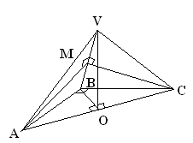
11. Soluţie:
Din ipoteză $Δ$ABC dreptunghic isoscel cu ipotenuza AC =$\sqrt{2}$
$⇒\text{AB}=\text{BC}=1$ .................1p VA=VB=VC=$\frac{\text{AC}}{\sqrt{2}}$$⇔\text{VA}=\text{VB}=\text{VC}=1$…………1p
Cum $Δ$VAB $Δ$VBC echilaterale$⇒\text{MA}=\text{MC}$, deci MA+ MB minima daca MA este minim.................................2p
MA minim daca $\text{AM}⊥\text{VB}$;......................1p
ΔVAB echilateral$⇒$MA=$\frac{\sqrt{3}}{2}$$⇒$$P_{Δ\text{MAC}}=\sqrt{2}+\sqrt{3}$, ..............1p+1p
Fie O mijlocul laturii AC, atunci:
$A_{\text{MAC}}=\frac{\text{AC}⋅\text{MO}}{2}=\frac{\sqrt{2}⋅\frac{1}{2}}{2}=\frac{\sqrt{2}}{4}$........................2p
b) VA=VB=VC$⇒$${\text{pr}}_{(\text{ABC})}V=$centrul cercului circumscris triunghiului ABC ={O} $⇒d(V,(\text{ABC}))=\text{VO}$=$\frac{\sqrt{2}}{2}$
2p............................................................................................3p

